Purpose

This report summarizes the testing performed to modify the calibration pass/fail requirement intended to be implemented in v. 0.9.9.1 of the ClearView Software Solution.

- Background

The calibration pass/fail requirement was determined and documented in Engineering Study, ENG-006 using the ClearView Software Solution version 0.9.7.8. Engineering Study ENG-006 recommended the implementation of a calibration pass/fail criteria. Images identified as pass and fail by a qualitative assessment were analyzed using statistical methods to develop 95% confidence limits for the intensity measurement of each of the 76,800 pixels within a calibration image. The software was set to fail the calibration process if one or more of the images within a calibration set contained a total of 10% or more pixels identified as failing the 95% confidence limit. This analysis process was then implemented in version 0.9.9.1 of the ClearView Software Solution.

Testing was completed to verify that the modified calibration process implemented in the ClearView Software Solution works as expected. The testing included the following:

- Camera Functions ClearView Software Solution v. 0.9.9.1 Validation (ENG-010)- Verified that all user interface camera functions- autocalibration, EPIC Administrator load of images, EPIC Administrator Duty Cycle Testing, etc- work as expected. This validation determined that all expected performance criteria were met.
- NewCal_Images Testing- The first set of images used in the development of the calibration pass/fail criteria, NewCal_Images, were qualitatively assessed during the original testing to determine the appropriate pass/fail determination. The images were loaded into the ClearView Software Solution v. 0.9.9.1 and assessed using the calibration pass/fail criteria. The results of this assessment are located in Attachment A. This assessment identified all of the failed images from SN0007 and all of the passed images from SN0009 and SN0025. However, the failed images from SN0009 and SN0025 (a total of 40/120 images), were identified as pass.
- AdHoc_Images Testing- A second set of images used in the development of the calibration pass/fail criteria, AdHocNewCal_Images, were qualitatively assessed during the original testing to determine the appropriate pass/fail determination. The images were loaded into the ClearView Software Solution v. 0.9.9.1 and assessed using the calibration pass/fail criteria. The results of this assessment are located in Attachment B. This assessment identified two images as Failed though the qualitative assessment identified these images as passed. Additionally, the ClearView assessment identified 168 images as passed which includes seven (7) images that were qualitatively determined to be Failed images.

The results of the ClearView analysis identified a weakness in the original criteria implemented. Although the criteria accurately identified failed images (i.e., those from SN0007 in the NewCal_Images) where the images lack of intensity was uniform throughout the entire image, the criteria did not detect unacceptable images where the lack of intensity was identified as clustered in specific sections of the image. An example of this result is highlighted below.

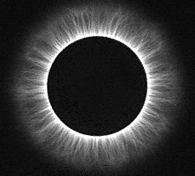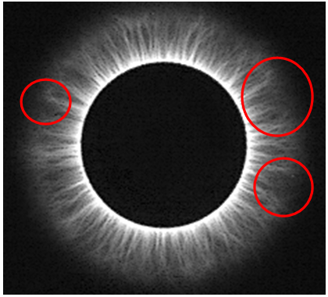
Original Image Same Image Highlighting areas of
non-uniform intensity.
In the case of this example (NewCal_Images test sample, SN25_04_1L), the image was categorized as Fail by the qualitative assessment and Pass by the ClearView software. Based on these results, a new method for determining appropriate calibration was pursued and developed. This report summarizes the results of the development testing performed to establish the new criteria.

- Investigation

The images qualitatively assessed as Fail which passed the proposed ClearView software calibration process were reviewed using a color enhancement to identify the location of pixels which fall outside the 95% confidence limits. The image below (AdHocNewCal_Images, SN09_D1_01_AM_Cal) represents the analysis that was performed.

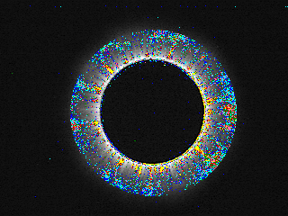

Each pixel that falls outside the 95% confidence limit is colored. Cooler colors (dark blue, light blue, green, etc.) represent 1-7 intensity levels outside the confidence limits while warmer colors (yellow, orange, red, etc.) represents 7-25 or more intensity levels outside the confidence limits. A review of this evaluation identified several issues with the proposed calibration assessment.

- Some of the images which were identified as Pass by the ClearView and Fail by the qualitative assessment would have sections of pixels within the calibration image whose intensities fall significantly outside the confidence limits. In these instances, the overall percentage of failure was less than 10%, but the qualitative assessment identified the lack of uniformity in the energized portion of the image and failed the image based on that assessment. Conclusion- The pixel failure percentage needs to be maximized to detect failures without increasing the false failure rate (i.e., risk of failing an image that was qualitatively assessed as Pass). Additionally, the pixels geographically located within the energized image are more significant to identifying images that should pass or fail than the pixels outside the energized image (which should remain dark). The confidence intervals were equally applied to all pixels regardless of their geographical location within the image. The intensity pass/fail criterion for each pixel needs to be assessed to determine if tighter standards need to be applied to the pixels within the energized portion of the image in order to more accurately identify failed images.
- When assessing the SN07 failures using the pixel coloring above, a significant ring of failures was identified on the inner edge of the calibration image even though the inner edge of the image was not what led to the original qualitative analysis failure. This cause of this inner edge failure was identified as resulting from the differences in orientation of the camera, thus the images taken by the different devices. An example can be seen below in that the SN07 image is physically higher and to the left within the image field than the SN09 image.
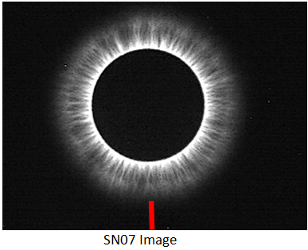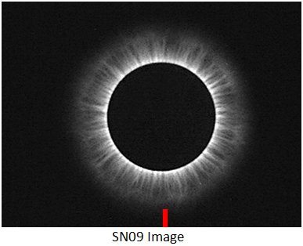

Conclusion- The pass/fail criteria needs to make an assessment of the beginning of the inner edge of the calibration image and orient the confidence interval pixel pass/fail criteria from there rather than from a fixed pixel location with the image field.

- Proposed Solution and Results of Preliminary Testing

Although several possible solutions were investigated, this report will summarize the final version identified as the final proposed criteria.

The original confidence intervals were based on a random sample of 46 images collected on two devices (SN0025 and SN0007). The first step taken to resolve the identified concerns was to obtain all 320 images assessed as Pass by the qualitative assessment in both the AdHocNewCal_Images and the NewCal_Images from all three devices (SN0007, SN0009, and SN0025). The inner edge of the energized image was determined and oriented in order to equate the location of the probe in the image between devices. The individual pixel intensities for each of the images were then calculated. The oriented pixel intensities were then used to calculate the average intensity and standard deviation for each pixel across all 243 images. Using the average and standard deviation, tolerance limits were established for each individual pixel (all 76,800). In order to address the concerns regarding the equivalent tolerance regardless of whether the pixel falls within the critical, energized image areas, different limits were established for the pixels which are located within the critical “zone”. The critical zone was defined as the established inner edge of the image and radiates out in concentric circles for approximately 100 pixels. A visual representation of the critical zone is represented in the image below by the red highlighted section of the image field .

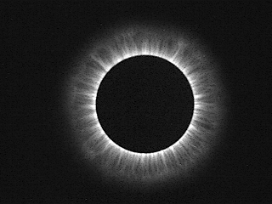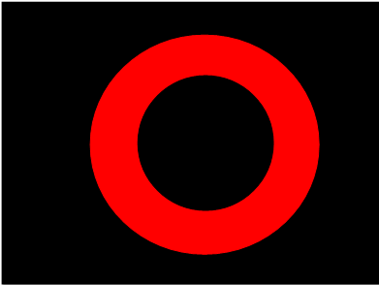
Energized Image Red, Critical Zone

The critical zone was assigned a pass/fail tolerance of +/-1 standard deviation from the average pixel intensity while the non-critical areas (visually displayed as black in the image above) were assigned a pass/fail tolerance of +/-3 standard deviations from the average pixel intensity. As in the previous ClearView software solution calibration acceptance criteria, these pass/fail tolerances will be used to establish the total number of failed pixels. The next step was to establish the appropriate level of failed pixels to identify acceptable calibration images from unacceptable calibration images.

All 350 of the qualitatively assessed calibration images, including both pass and fail images, were then passed through the following process:

- Measurement of pixel intensities for each of the 76,800 pixels.
- Comparison of the measured pixel intensity to the tolerance limit for the pixel (i.e., +/-1 standard deviation for a critical pixel and +/-3 standard deviation for non-critical pixels). Pixels with measured intensity values outside the tolerance limits are identified as failed.

The total number of failed pixels for each image was determined. Table 1 below provides the resulting pass/fail assessments for each group of images. Five different possible acceptance limits for the total number of failed pixels were proposed based on the total number of pixels; 10%=7680 pixels, 9.5%=7296 pixels, 9.0%=6912 pixels, 8.5%=6528 pixels, or 8.0%=6144 pixels.

Percent Cutoff | Acceptable Number of Pixels | Adhoc Fail (7) |  |  | Adhoc Pass (163) |  |  | NewCalFail (100) |  |  | NewCAlPass (80) |  |  | Overall Percent Agreement
Percent Cutoff | Acceptable Number of Pixels | Pass | Fail | Percent Agreement | Pass | Fail | Percent Agreement | Pass | Fail | Percent Agreement | Pass | Fail | Percent Agreement | Overall Percent Agreement
10.00% | 7680 | 7 | 0 | 0.00% | 163 | 0 | 100.00% | 48 | 52 | 52.00% | 80 | 0 | 100.00% | 84.29%
9.50% | 7296 | 6 | 1 | 14.29% | 154 | 9 | 94.48% | 37 | 63 | 63.00% | 80 | 0 | 100.00% | 85.14%
9.00% | 6912 | 5 | 2 | 28.57% | 150 | 13 | 92.02% | 23 | 77 | 77.00% | 80 | 0 | 100.00% | 88.29%
8.50% | 6528 | 1 | 6 | 85.71% | 142 | 21 | 87.12% | 13 | 87 | 87.00% | 80 | 0 | 100.00% | 90.00%
8.00% | 6144 | 0 | 7 | 100.00% | 127 | 36 | 77.91% | 9 | 91 | 91.00% | 68 | 12 | 85.00% | 83.71%

The proposed new calibration analysis was then implemented into version 0.9.9.1 of the ClearView Software Solution. The same 350 images were loaded into the calibration analysis and tested using the software. The results (pass/fail) of this analysis were recorded in a table matching the qualitative assessment with the ClearView software analysis result. These tables are located in Attachment B of this report. The table below summarized the results.

Percent Cutoff | Acceptable Number of Pixels | Adhoc Fail (7) |  |  | Adhoc Pass (163) |  |  | NewCalFail (100) |  |  | NewCAlPass (80) |  |  | Overall Percent Agreement
Percent Cutoff | Acceptable Number of Pixels | Pass | Fail | Percent Agreement | Pass | Fail | Percent Agreement | Pass | Fail | Percent Agreement | Pass | Fail | Percent Agreement | Overall Percent Agreement
8.50% | 6528 | 1 | 6 | 85.71% | 142 | 21 | 87.12% | 13 | 87 | 87.00% | 80 | 0 | 100.00% | 90.00%

This testing confirms that the results identified during the development testing match the results obtained from the implementation of the coding of the software. Thus, the testing confirms that the proposed calibration analysis process was successfully implemented into the software.
- Conclusions and Recommendations

The proposed calibration analysis process has demonstrated an ability to determine acceptable calibration images with a 90% agreement with the qualitative assessment. This process has been identified as an acceptable method for determining device performance prior to use in the collection of human subject data. A software validation will be performed on the revised version 0.9.9.1 in order to establish that no unintended changes were also made in the user functions of the software.

- Attachments

Attachment A, NewCal and AdHoc Image Test Results – Original Pass/Fail Criteria
Attachment B, NewCal and AdHoc Image Test Results – Modified Pass/Fail Criteria

